*//Loc Nguyen*

#include <iostream>

#include <string>

#include <iomanip>

**using** **namespace** std;

**int** voteYes=0, voteNo=0,counter=1,one=1;

**char** c;

**void** printStars(){

cout<<'*';

}

**void** displayY(){

cout<<"Number of YES votes = "<< voteYes<< " = ";

}

**void** displayN(){

cout<<"\nNumber of No votes = "<< voteNo<< " = ";

}

**void** readChar(){

cin.get(c);

}

**void** getString(){

cout<<"Enter a string of votes:";

}

**void** endLine(){

cout<<endl;

}

**void** (*endLineP)()= endLine;

**void** (*getStringPointer)()=getString;

**void** (*readCharPointer)()=readChar;

**void** (*displayPointer)()=displayY;

**void** (*displayPointerN)()=displayN;

**void** (*printStarPointer)()=printStars;

**int** main(){

**__asm**{

call getStringPointer;

whileLoop:

call readCharPointer;

cmp c, '\n';

je cont;

checkY:

cmp c,'y';

je addY;

checkNo:

inc voteNo;

jmp whileLoop;

addY:

inc voteYes;

jmp whileLoop;

cont:

call displayPointer;

whileY:

mov eax, counter;

cmp eax,voteYes;

jg cont2;

printY:

inc counter;

call printStarPointer;

jmp whileY;

cont2:

call displayPointerN;

mov counter,1;

whileN:

mov eax,counter;

cmp eax, voteNo;

jg done;

printN:

inc counter;

call printStarPointer;

jmp whileN;

done:

call endLineP;

}

**return** 0;

}

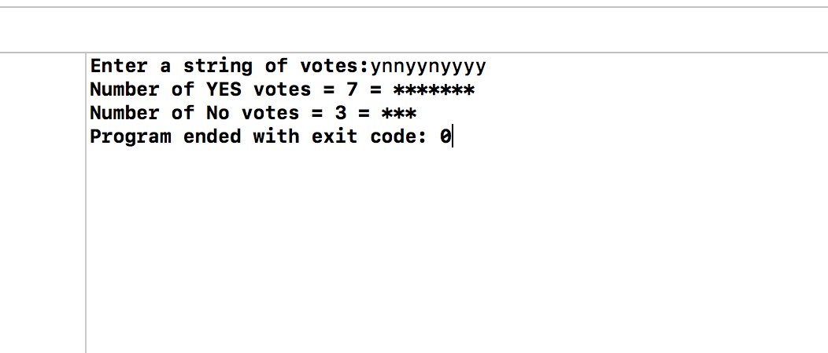

#2

#include <iostream>

#include <string>

**using** **namespace** std;

**char** c;

string output;

**void** getString(){

cout<<"Enter a sentence: ";

}

**void** getChar(){

cin.get(c);

}

**void** outputString(){

*//cout<<c; compare each char then output to screen. or just add char to string then output later.*

output+=c;

}

**void** getOutput(){

cout<<"Output: ";

}

**void** (*getOutputPointer)()=getOutput;

**void** (*outputStringPointer)()=outputString;

**void** (*getCharPointer)()=getChar;

**void** (*getStringPointer)()=getString;

**int** main(){

**__asm**{

call getStringPointer;

whileLoop:

call getCharPointer;

cmp c,'\n';

je done;

checkperiod:

cmp c,'.';

je done;

checkA:

cmp c,'a';

je changeA;

checkE:

cmp c,'e';

je changeE;

checkI:

cmp c,'i';

je changeI;

checkO:

cmp c,'o';

je changeO;

checkU:

cmp c,'u';

je changeU;

checkAll:

call outputStringPointer;

jmp whileLoop;

changeA:

mov c, 'A';

call outputStringPointer;

jmp whileLoop;

changeE:

mov c,'E';

call outputStringPointer;

jmp whileLoop;

changeI:

mov c,'I';

call outputStringPointer;

jmp whileLoop;

changeO:

mov c,'O';

call outputStringPointer;

jmp whileLoop;

changeU:

mov c,'U';

call outputStringPointer;

jmp whileLoop;

done:

call outputStringPointer;

}

cout<<"Output: "<<output<<endl;;

**return** 0;

}

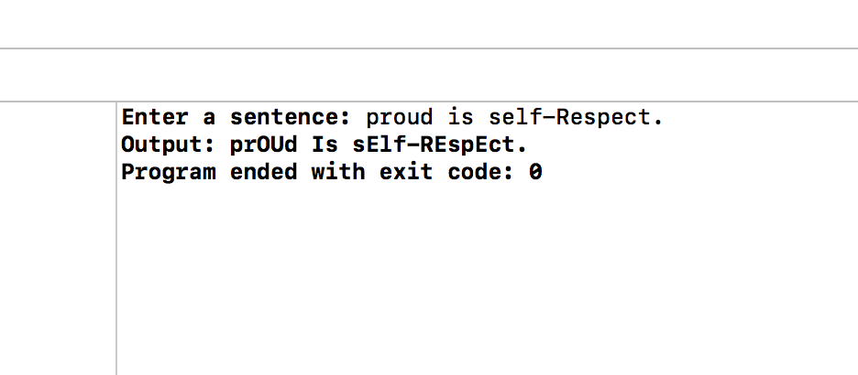

#3

#include <iostream>

#include <ctime>

**using** **namespace** std;

**char** choice,choiceYN;

**int** answer,inputAnswer,adWrong,adCorrect,minusCorrect,minusWrong;

**void** getChoice(){

adWrong=0;

adCorrect=0;

minusCorrect=0;

minusWrong=0;

cout<<"Enter your choice(a/b):";

cin>>choice;

}

**void** getInt(){

cin>>inputAnswer;

}

**void** displaySubAnswer(){

cout<< "No. of Correct answer= "<<minusCorrect<<endl;

cout<< "No. of Wrong answer= "<<minusWrong<<endl;

}

**void** displayAdAnswer(){

cout<< "No. of Correct answer= "<<adCorrect<<endl;

cout<< "No. of Wrong answer= "<<adWrong<<endl;

}

**void** getCont(){

cout<<"continue(y/n)?";

cin>>choiceYN;

choiceYN=tolower(choiceYN);

}

**void** getDone(){

cout<<"Are you done(y/n)?";

cin>> choiceYN;

choiceYN= tolower(choiceYN);

}

**void** displayA(){

srand(time(**NULL**));

**int** x = (rand()%100+1);

**int** y = (rand()%100+1);

cout<< x <<" + "<< y <<"=?";

answer= x+y;

}

**void** displayS(){

srand(time(**NULL**));

**int** x = (rand()%100+1);

**int** y = (rand()%100+1);

cout<< x <<" - "<< y <<"=?";

answer= x-y;

}

**void** displayR(){

cout<<"CORRECT\n";

}

**void** displayW(){

cout<<"WRONG\n";

}

**void** displayDone(){

cout<<"Have a nice Day\n";

}

**void** (*displayAdAnswerP)()=displayAdAnswer;

**void** (*displayDoneP)()=displayDone;

**void** (*getDoneP)()=getDone;

**void** (*displaySubAnswerP)()= displaySubAnswer;

**void** (*getContP)()=getCont;

**void** (*displayWP)()=displayW;

**void** (*displaySP)()=displayS;

**void** (*displayRP)()=displayR;

**void** (*getIntP)()=getInt;

**void** (*displayAP)()=displayA;

**void** (*getChoiceP)()=getChoice;

**int** main(){

cout<<"-----------Practice Addition & Subtraction------------"<<endl;

cout<<"a. Practice Addition\n";

cout<<"b. Practice Subtraction\n";

**__asm**{

_getChoice:

call getChoiceP;

mov al,choice;

cmp al,'a';

je addition;

subtraction:

call displaySP;

call getIntP;

mov eax, answer;

cmp eax, inputAnswer;

je SCorrect;

SWrong:

call displayWP;

inc minusWrong;

call getContP;

mov al,choiceYN;

cmp al, 'y';

je subtraction;

jmp numberOfAnswerS;

SCorrect:

call displayRP;

inc minusCorrect;

call getContP;

mov al,choiceYN;

cmp al, 'y';

je subtraction;

jmp numberOfAnswerS;

addition:

call displayAP;

call getIntP;

mov eax, answer;

cmp eax,inputAnswer;

je addCorrect;

addWrong:

call displayWP;

inc adWrong;

call getContP;

mov al,choiceYN;

cmp al, 'y';

je addition;

jmp numberOfAnswerA;

addCorrect:

call displayRP;

inc adCorrect;

call getContP;

mov al,choiceYN;

cmp al, 'y';

je addition;

jmp numberOfAnswerA;

numberOfAnswerA:

call displayAdAnswerP;

call getDoneP;

mov al, choiceYN;

cmp al, 'n';

je _getChoice;

numberOfAnswerS:

call displaySubAnswerP;

call getDoneP;

mov al, choiceYN;

cmp al, 'n';

je _getChoice;

done:

call displayDoneP;

}

**return** 0;

}